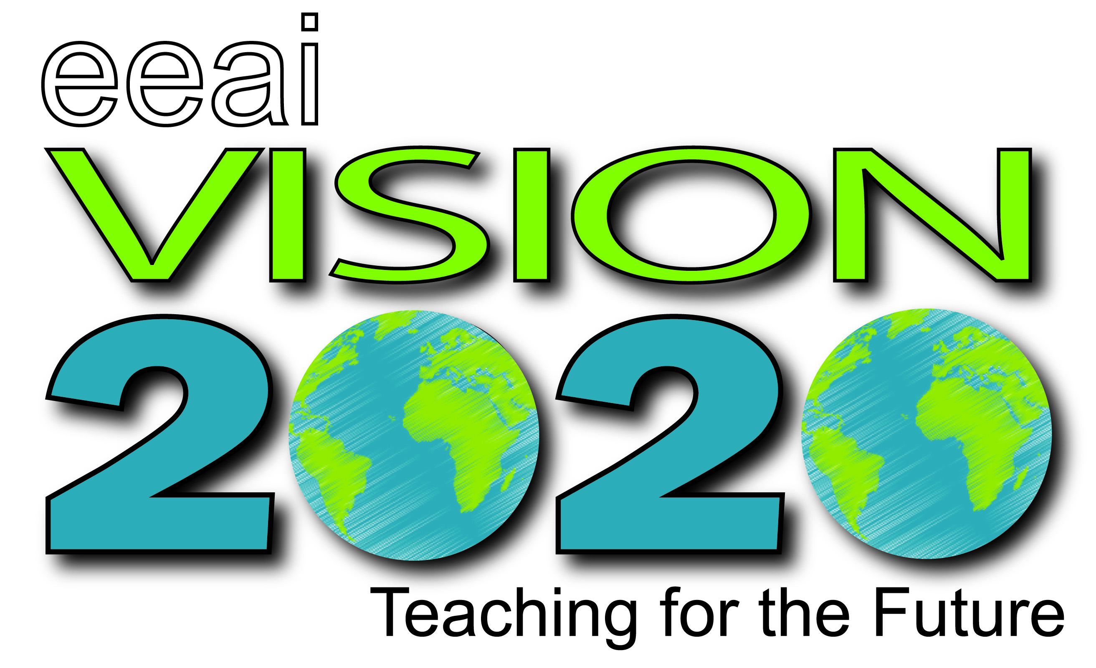
Camp Mack, Milford, IN
November 6-8, 2020

Call for Presenters

The Environmental Education Association of Indiana (EEAI) is seeking presenters for the annual EEAI Conference, November 6-8, 2020 at Camp Alexander Mack, 1113 E. Camp Mack Rd., Milford, IN, 46542.

We are anticipating about 125 + Pre K-12 educators, informal environmental educators, and administrators. The theme for this year’s symposium is EEAI Vision 2020: Teaching for the Future. As environmental educators, we need to have 20/20 vision to help others get outside, understand environmental concerns, and rejuvenate ourselves in the outdoors. Highlights of the conference include keynote speakers Rachel Larimore and David Sobel, field trips to regional natural hotspots, pre and/or post conference workshops, the infamous song contest, and great networking opportunities.

We are looking for presenters around the following tracks related to the conference’s theme:
- Nature Based Early Childhood Education/Early Childhood Environmental Education
- K-12 Formal Education
- Non Formal Environmental Education
- Administration

We are hoping for interactive presentations and/or workshops, some of which may be outside. Please submit all proposals by close of business on May 15th, 2020 to the Google Form (https://forms.gle/zsXsKFxmw9rnoGEA9). Feel free to reach out with questions to Dr. Carla Gull, conference cochair, at insideoutsidemichiana@gmail.com.

Apply to Present TODAY!
http://eeai.org

EEAI Vision 2020: Teaching for the Future Proposal Form
November 6-8, 2020
Camp Alexander Mack
1113 E. Camp Mack Rd., Milford, IN, 46542

Presenter Information

Name:
Organization:
Address:
Phone Number:
E-mail:
Name(s) of co-presenters:
Brief Bio (50 words) and Pertinent Education and Experience:

Presenters are responsible for lodging, transportation, and any teaching materials you may need. Camp Mack has several indoor and outdoor spaces available. Please let us know in the description below which would work best for your specific needs.

Presentation Information
Presentations are typically 60 minutes in length. We would prefer hands-on, interactive presentations that will further connect participants to environmental education concepts.

Presentation Title (10 word limit):

Description of presentation to appear in program (40 word limit):

Which strand does your presentation fit in?
- Nature Based Early Childhood Education/Early Childhood Environmental Education
- K-12 Formal Education
- Non Formal Environmental Education
- Administration

Describe your workshop in more detail below for review purposes. Please include:
- How many participants (approximately) you could accommodate
- Your space and classroom requirements (indoors/outdoors, overhead projector, etc.)
- Workshop materials
- Teaching intentions
- Expected outcomes
- How your workshop fits the theme of Vision 20/20: Teaching for the Future

Proposals are due to Dr. Carla Gull at the Google Form (https://forms.gle/zsXsKFxmw9rnoGEA9) by close of business on May 15th, 2020. Questions? Feel free to contact us! Presenters will be notified by mid-Summer of acceptance of the proposal. Thank you for giving back to the environmental education profession with your expertise!

